**SCCM (System Center Configuration Manager)**

**Microsoft System Center Configuration Manager (SCCM) is a Windows product that enables administrators to manage security and deployment of applications.**

**SCCM (System Center Configuration Manager)** is a Microsoft tool used by IT administrators to manage, deploy, and secure applications and devices across an enterprise. It helps with:

* **Software deployment**
* **OS updates and patching**
* **Device and compliance management**

It's part of the **Microsoft System Center suite**, designed for centralized IT management in large organizations.

**Steps of how SCCM works:**

* **Step1:** To install the application, **create packages in the SCCM console** which consists of the **command line** and **executed files**.
* **Step2:** **Configuration manager admin** creates **virtual application packaging** and replicates it to selected **Distribution Points**. (Distribution points are nothing but file servers which store the packages for a particular region like **APAC(Asia-Pacific)**, **EMEA(Europe, Middle East and Africa)**, **US(United States of America)**).
* **Step3:** If the user wants to download any application, then the user can directly download the application from the distribution points rather than connecting to the SCCM primary server.
* **Step4:** Now, install the SCCM agent which helps a machine communicate with the SCCM servers.
* **Step5:** In this step, the SCCM agent keeps on checking for the new policies and deployments. Using the updates SCCM admin creates deployment where an application is targeted on a bunch of machines.
* **Step6:** Once the policy reached the end machine, the SCCM agent evaluates the policy and reaches out to its particular regional distribution points for downloading the packages.
* **Step7:** Once the executed files are downloaded in a temp folder, users can install those packages in the local system. Now the file status is sent back to the SCCM server to update in the database.
* **File status –** end user in vm installed application and utilized.

These are the basic steps. In the background, more tasks may happen, but the main components—**packages, DPs, SCCM agents, and servers**—stay the same in all environments.

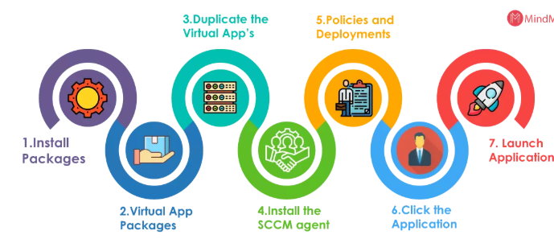

**Major & Basic Features of System Centre Configuration Manager(SCCM)**

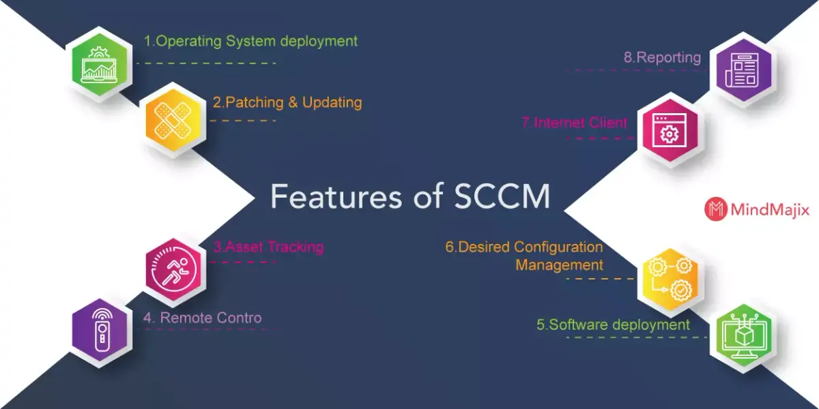

**Active Directory Forest (AD Forest)**

**What is an Active Directory Forest (AD Forest)?**

An **Active Directory Forest** is the **top-level container** in an Active Directory (AD) environment. It is the **highest level of security boundary** that holds all **domains**, **users**, **computers**, and **resources** in a Microsoft network.

**Key Features:**

* **Single Database & Global Address List** for the entire forest.
* **Security Boundary** between forests.
* Supports **Group Policies**, **Authentication**, and **Authorization**.
* Allows **multiple domains** within one forest.

**How to Create an AD Forest:**

1. Install **Windows Server**.
2. Add **Active Directory Domain Services (AD DS)** and **DNS Server** roles.
3. Use the **AD DS Configuration Wizard** to create a new forest.
4. Choose a **root domain name** and complete the setup.

**Advantages:**

* Centralized user and resource management.
* Can apply group policies for security and configuration.
* Supports security groups for access control.

**Disadvantages:**

* Complex to manage if using **multiple forests**.
* Higher cost and increased configuration effort.
* Security risks if not properly isolated or configured.

**Forest Design Models:**

1. **Organizational Forest Model** – One forest for all resources.
2. **Resource Forest Model** – Separate forests for resources with trust.
3. **Restricted Access Forest Model** – No trust between forests (high security).

**Single vs. Multi-Forest Design:**

* **Single Forest** – Simpler, cheaper, ideal for small to mid-sized organizations.
* **Multi-Forest** – More complex, used for large enterprises with strict isolation needs.

**In SCCM:**

* **AD Forest Discovery allows SCCM to find and manage resources across all trusted domains in a forest.**
* **Helps with client installation, site assignment, and publishing SCCM services.**

**Example of Active Directory Forest (AD Forest)**

